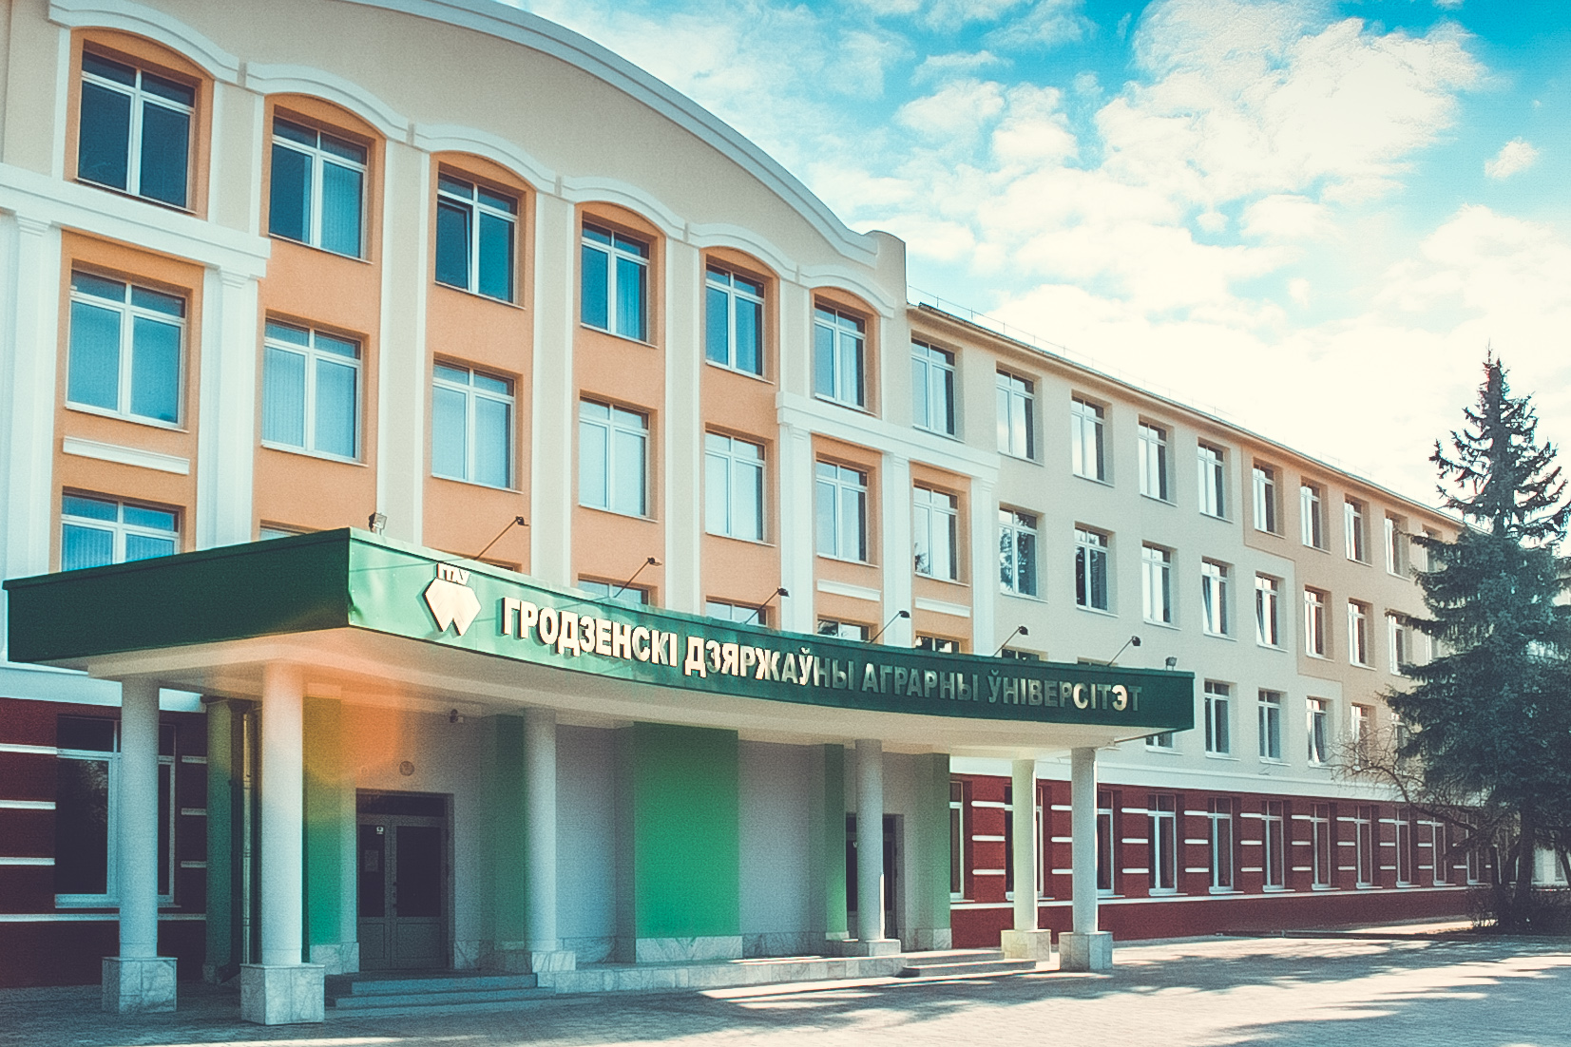  Main university building  What does University offer you?  - high-quality academic staff – highest level professionals in fields of experience;  - especial educational environment – a comfortable and warm atmosphere dominates at the University. Teachers give classes in small groups and use an individual approach to students’ need;  - student-centered approach – and helpful staff;  - reasonable cost of education and accommodation – our University is a nonprofit organization that allows us to keep tuition fee at acceptable level;  - we are committed to providing education that meets the requirement of students, employers and the community as a whole. |  | 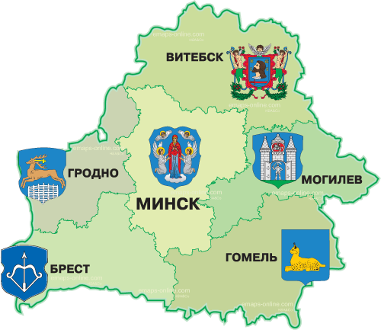 | About University  Educational institution “Grodno State Agrarian University” is a dynamically developing multifunctional scientific center in the West region of the Republic of Belarus training specialists of the highest qualification.  Contact Information  For all Nigerians apply through our official representative guzye investments ltd +2348033513638,+375297739702  guzyeinvest@yahoo.co.uk.  www.guzyeconsulting.com  Telephone: +375 152 74 04 39  Telephone/Fax: +375 152 72 13 65  e-mail: inter@ggau.by  inter.ggau@yandex.ru  www.ggau.by  International Cooperation Office: http://ggau.by/world/info-ennglish  Educational institution “Grodno State Agrarian Unversity”  28 Tereshkowoi St.  230008, Grodno |  |  | Educational institution “Grodno State Agrarian University”  - Nothing but good opening!  2015

Preparatory Department  1. Preparatory department for foreigners (economical specialization);  2. Preparatory department for foreigners (biological specialization).  Period of training – 10 months. |  |  | Tuition Fee  Preparatory Department: 1800$  Higher Education of the first  level: 2200 $  Master degree program: 2500 $  Postgraduate training program: 3500 $  Admission documents:  - Complete secondary education certificate with subjects studied and marks obtained;  - Medical certificate of health status and certificate confirming negative HIV status issued by a health care authority of an applicant’s country origin; |  |  | - Birth certificate;  - 8 photos sized 34 cm.  The above listed documents should be translated into Russian and notarized.  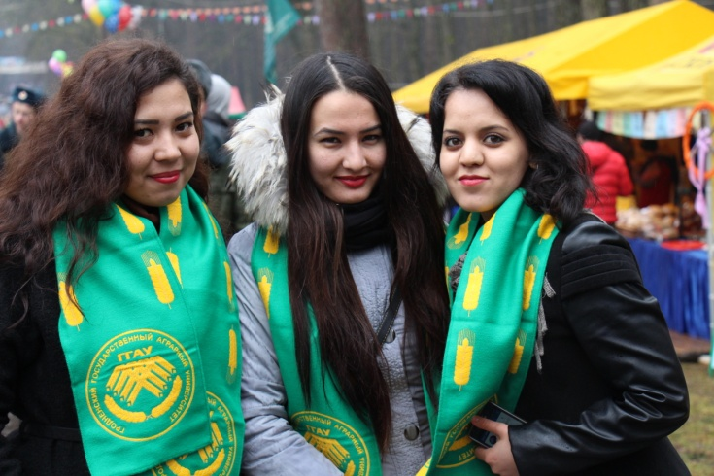  Students from Turkmenistan, Russia, Kazakhstan, Kyrgyzstan, Nigeria, Cameroon, Ecuador, Iraq and Lithuania study annually at the University.  All international students are provided with a room in a university hostel. Thanks to the outstanding services, compact campus and active academic society international students feel at home from the very beginning of their stay.  - We look forward to welcoming You!

