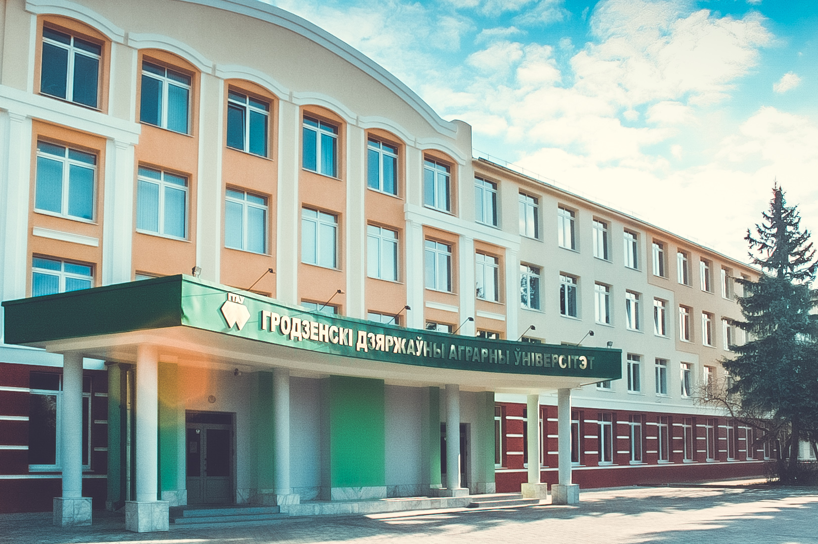  Main university building  WhatdoesUniversity offer you?  - high-qualityacademicstaff – highestlevelprofessionalsin fields of experience;  - special educational environment– a comfortable and warm atmosphere dominates at the University. Teachersgiveclassesinsmallgroupsandusean individual approach to students’ need;  - student-centered approach–and helpful staff;  - reasonable cost of education and accommodation –our University is a nonprofitorganizationthat allows us to keep tuition fee at acceptable level;  - we are committed to providing education that meets the requirement of students, employers and the community as a whole. |  | 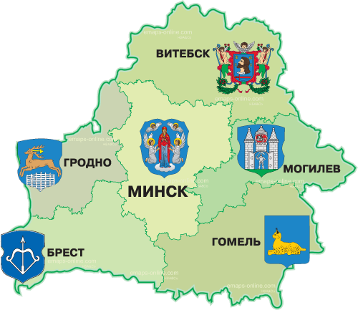

Preparatory Department  1. Preparatory department for foreigners(economical specialization);  2. Preparatory department for foreigners(biological specialization).  Period of training– 10 months. |  |  | Tuition Fee  Preparatory Department:1800$  Higher Education of thefirst  level: 2200 $  Master degree program: 2500 $  Postgraduate training program: 3500 $  Admission documents:  -Complete secondary education certificate with subjects studied and marks obtained;  -Medicalcertificateofhealthstatusandcertificateconfirmingnegative HIV status issued by a health care authority of an applicant’s country origin; |  |  | - Birth certificate;  -8photos sized 34 cm.  The above listed documents should be translated into Russian and notarized.  Studentsfrom Turkmenistan, Russia, Kazakhstan, Kyrgyzstan, Nigeria, Cameroon, Ecuador, IraqandLithuaniastudy annually at the University.  All international students are provided with a room in a university hostel. Thanks to the outstanding services, compact campus and active academic society international students feel at home from the very beginning of their stay.  - We look forward to welcoming You!

